Practical 4 :
Develop experiential understanding of Layer-3 communication by configuring interconnected networks, analyzing router forwarding decisions, routing tables, default gateways, ARP operation and TTL changes, and implementing static routing using Cisco Packet Tracer and Linux-based packet observation.

Pr 4.1 : Single Router
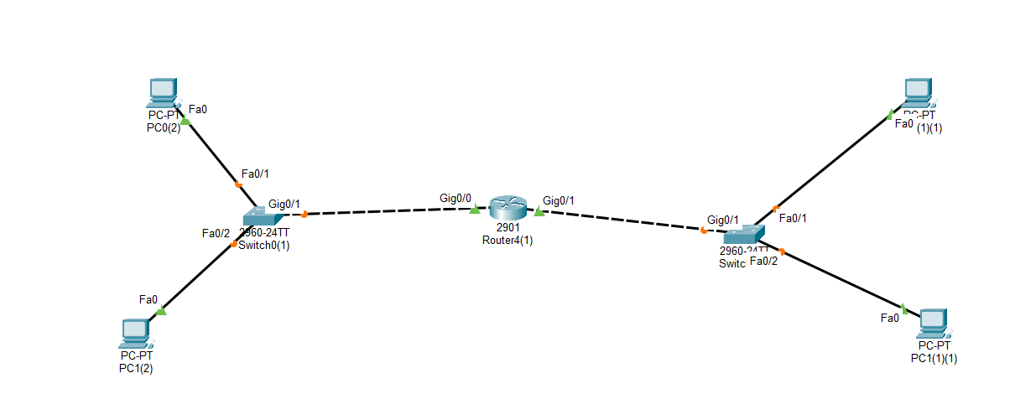
Figure 1 Layout of the Circuit

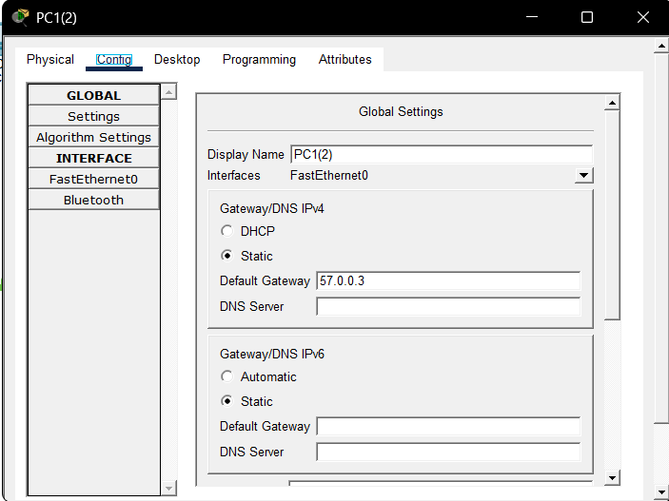

Figure 2 Setting IP Address To all Pc's

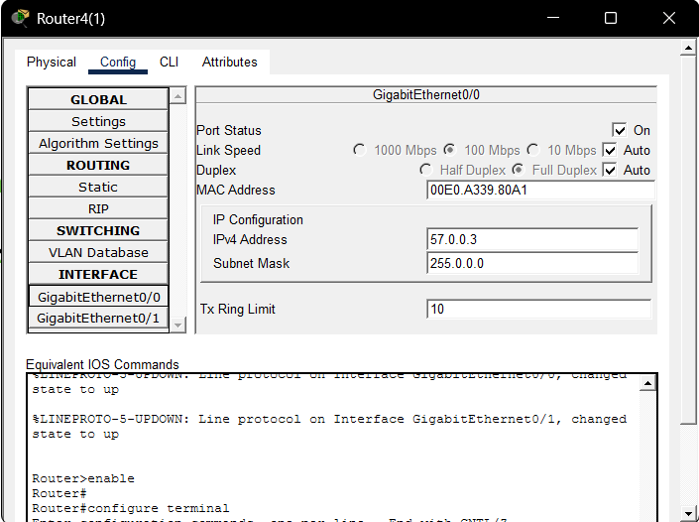

Figure 3 Setting IP Address to Router

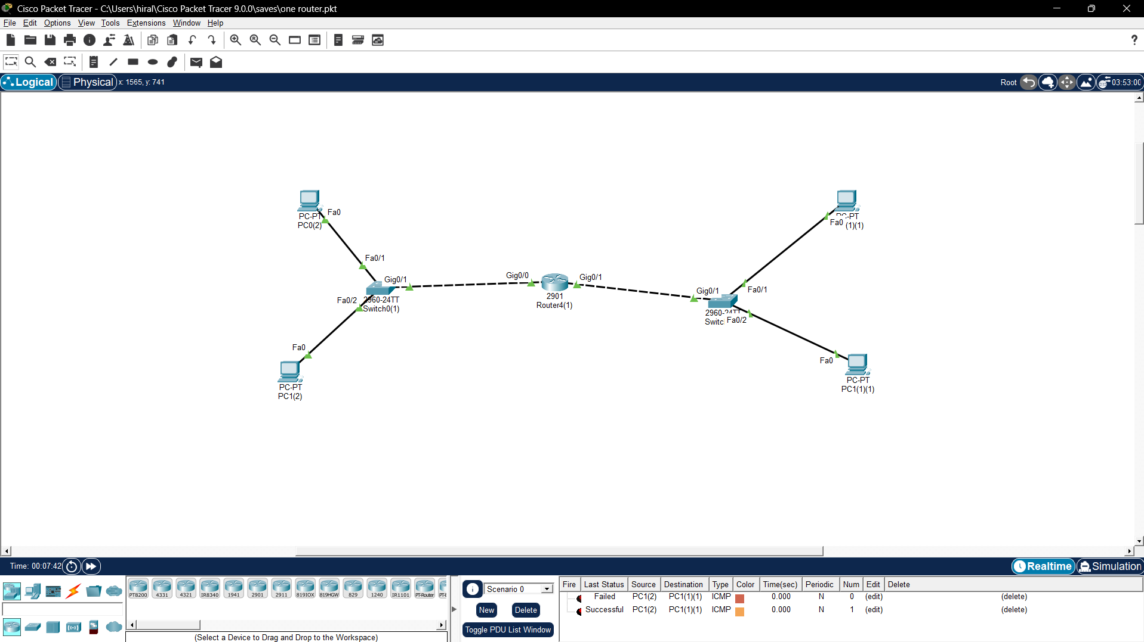

Figure 4 Successfully Received Message from Network 1 to Network 2

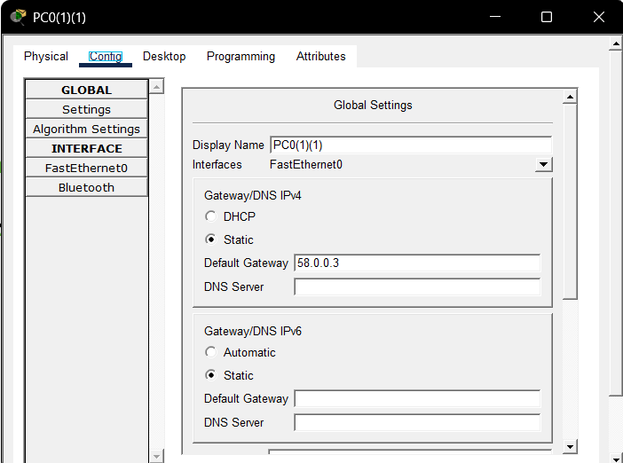

Figure 5 Default Gateway Assigned

Pr 4.2 : Three Router

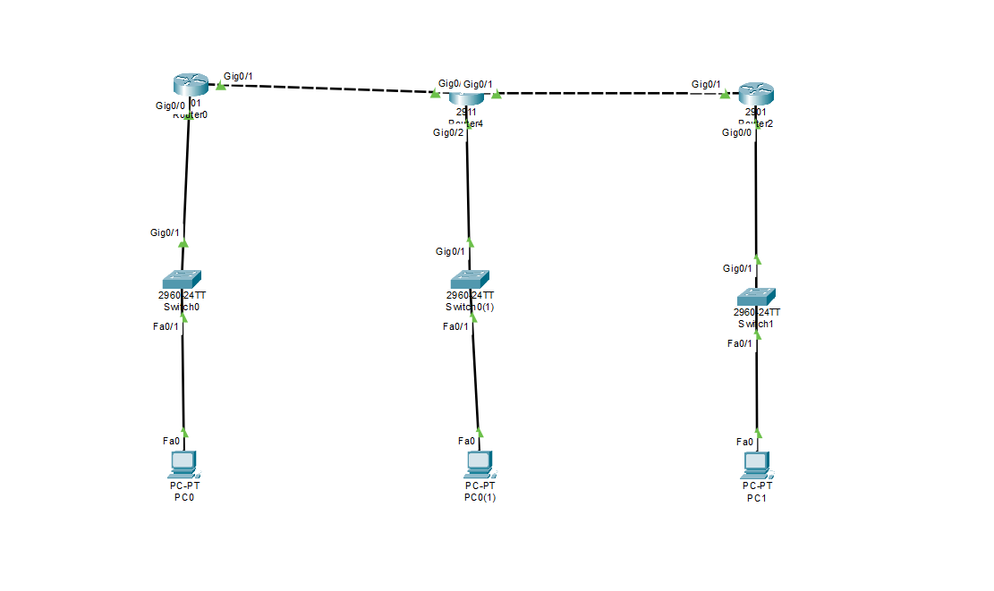
Figure 6 Circuit Diagram of Three Router

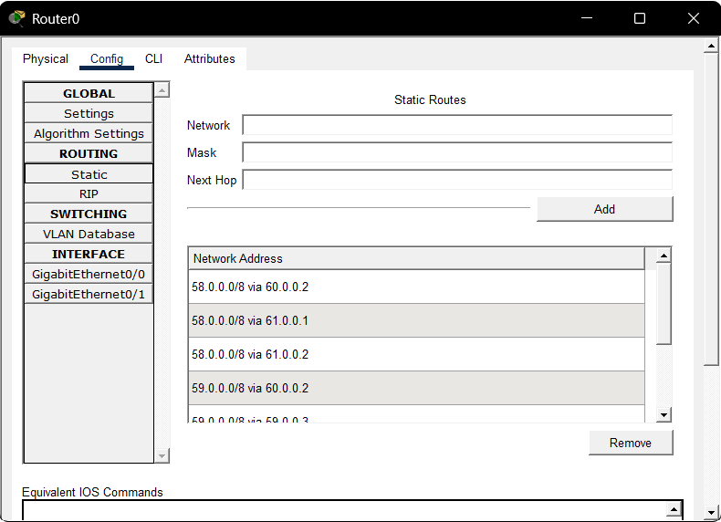

Figure 7 Static Routing

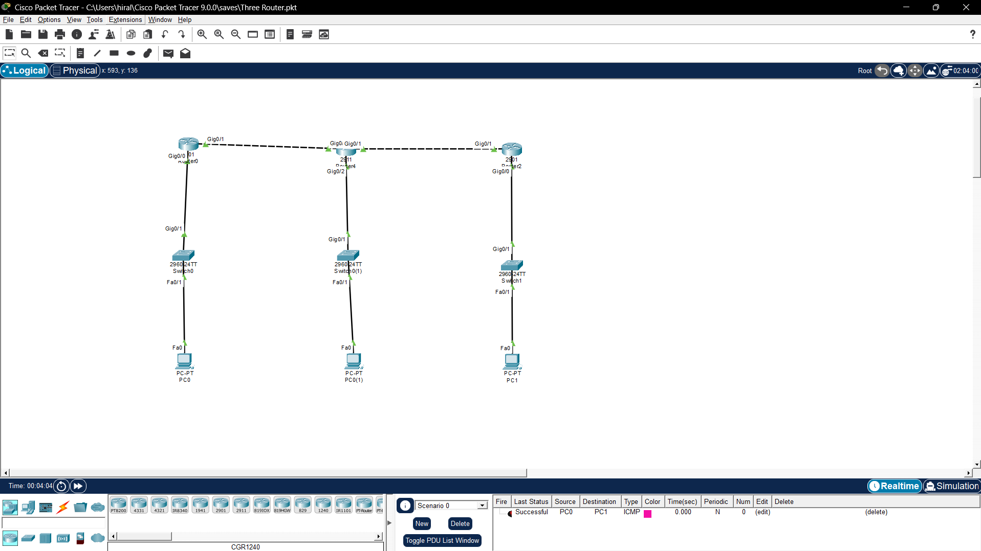

Figure 8 Message Arrived at PC2 from PC0

